BETTer Project

### Group members

Franco Evett

Anas

Anthony

Romi

Pruthvi

Camron

Felipe

## Learning Objective For Brief

LO1: Plan, manage and track a substantial group activity.

LO2: Take an open-ended problem, collect and analyse relevant information and define and refine the requirements.

LO3: Independently and systematically design, develop and test a piece of software that is data-driven and has non-trivial functionality.

LO4: Compare and evaluate alternative problem solutions according to given criteria including from a technical perspective.

LO5: Effectively present, communicate and market ideas and solutions to different audiences.

LO6: Understand and apply the principles of professional and ethical behaviour in a group context.

LO7: Reflect and learn from the group project experience.

## 

## Group Meeting Agenda 21/11/2019

### Project Discussion

1. Make sure everybody is on the same page and knows what the project is
2. Collect ideas on the project
3. Discuss requirements
4. Interface Discussion
5. GUI Discussion
6. Discussion on project timescale estimation

### Communication

1. Resend the discord link because it expired
2. Find a day each week to have a group meeting
3. Who lives on campus/travel times
4. Record each group meetings content for the project writeup
5. Set names on discord and WhatsApp to actual names
6. Discuss GitHub project management

### Team Skills Discussion

1. How many people in the group can program
2. Who is good a GUI designer

### Work For Next Week

1. Requirements Specification - Romi
2. Risk analysis - Camron
3. GUI Design - Anthony
4. Entity Relationship Diagram - Anas
5. Use Case Expansion - Franco
6. Data Scraping - Pruthvi
7. Document Planning ?
8. Interface ?
9. security ?

### 

### Agenda Accomplishments - 21/11/2019

1. Create a GItHub repository
2. Add everyone to GitHub repository
3. Organised a new meeting time each week
4. Discussed the project concept
5. Discussing the project timescale
6. Drawn basic GUI design for the project
7. Assigned tasks to everyone (Design Phase)

### Requirements:

The below data is an outline that needs to be written up in a pull page report. An explanation describing the system and what features it will have followed by a bullet point list of features.

User Requirements:

1. Easy access to timetable
2. Notifications
3. Settings
4. Create Events
5. Travel Time

System Requirements:

1. Database
2. Notification System
3. User Account Information + Login System
4. Lab Setup - Select Your Labs
5. Create Events
6. Easy Main Display

## Group Meeting Agenda 26/11/2019

### Assigned Work Discussion

1. Last meeting (very close to this meeting)
2. Work Needs to be done
3. Some members have done work but not uploaded it

### Communication

1. Work Needs to be Uploaded to Github to show weekly progression and allow for group review

### Work For Next Week

1. Requirements Specification - Romi
2. Risk analysis/Security - Camron
3. GUI Design - Anthony
4. Class/Entity Relationship Diagram - Anas
5. Use Case Expansion - Franco
6. Data Scraping - Pruthvi

This has been uploaded to Github its the basic process of how the app will work. Use this to base all of the entities required the GUI pages needed and so forth.

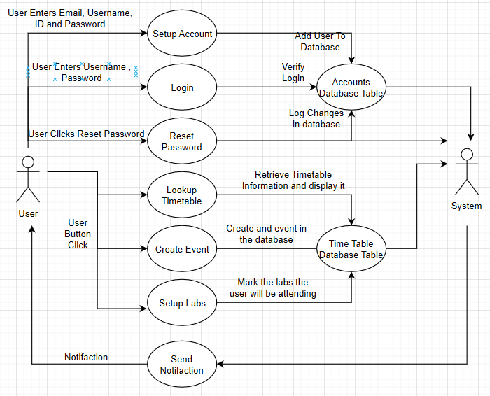

## Group Meeting Agenda 3/12/2019

### Assigned Work Discussion

1. Well done to those who have completed work and uploaded it to github
2. Please add an upload comment to the commits
3. Impending deadline need work to be completed NOW
4. Discuss beginning prototype development

### Work Completed This Week

1. Requirements Specification - Romi IN PROGRESS
2. Risk analysis/Security - Camron IN PROGRESS
3. GUI Design - Anthony NOT UPLOADED
4. Class/Entity Relationship Diagram - Anas COMPLETE
5. Use Case Expansion - Franco COMPLETE
6. Data Scraping - Pruthvi ON SCEDULE
7. Terms & Conditions - Felipe ASSIGNED

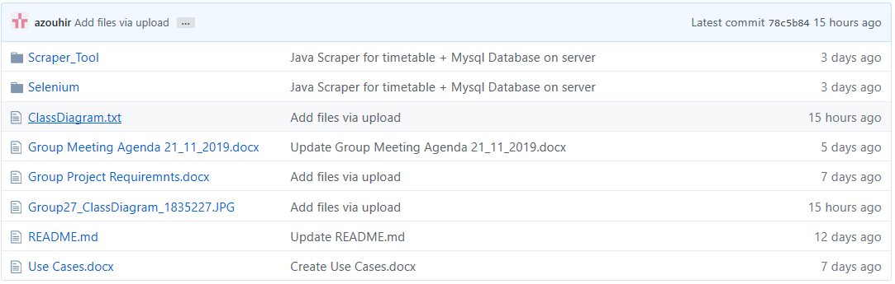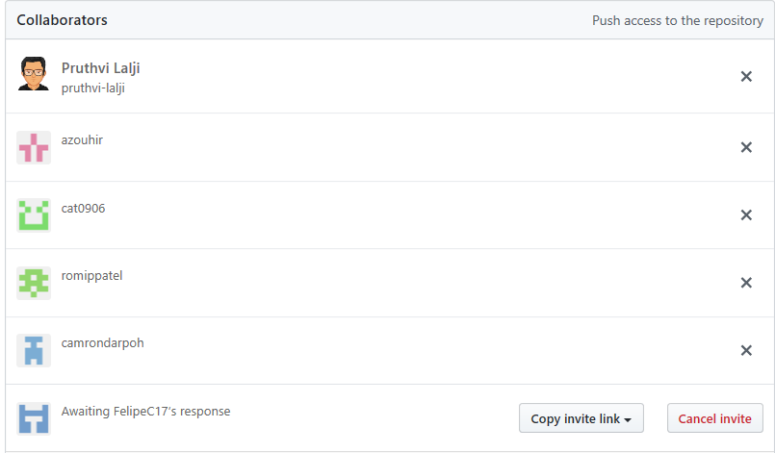

## Work Completed Review

### Class Diagram / Interface

Very Good - Please add a User Class that will be instantiated as an Object for data manipulation purposes - This call will be placed in the model part of the system as it is data oriented

Uses - Add the type of event to the model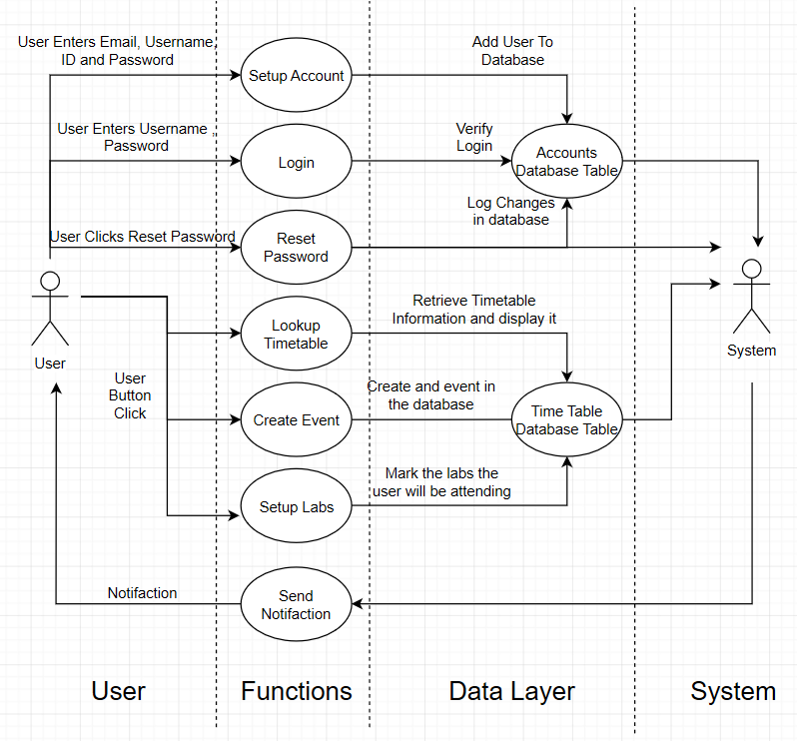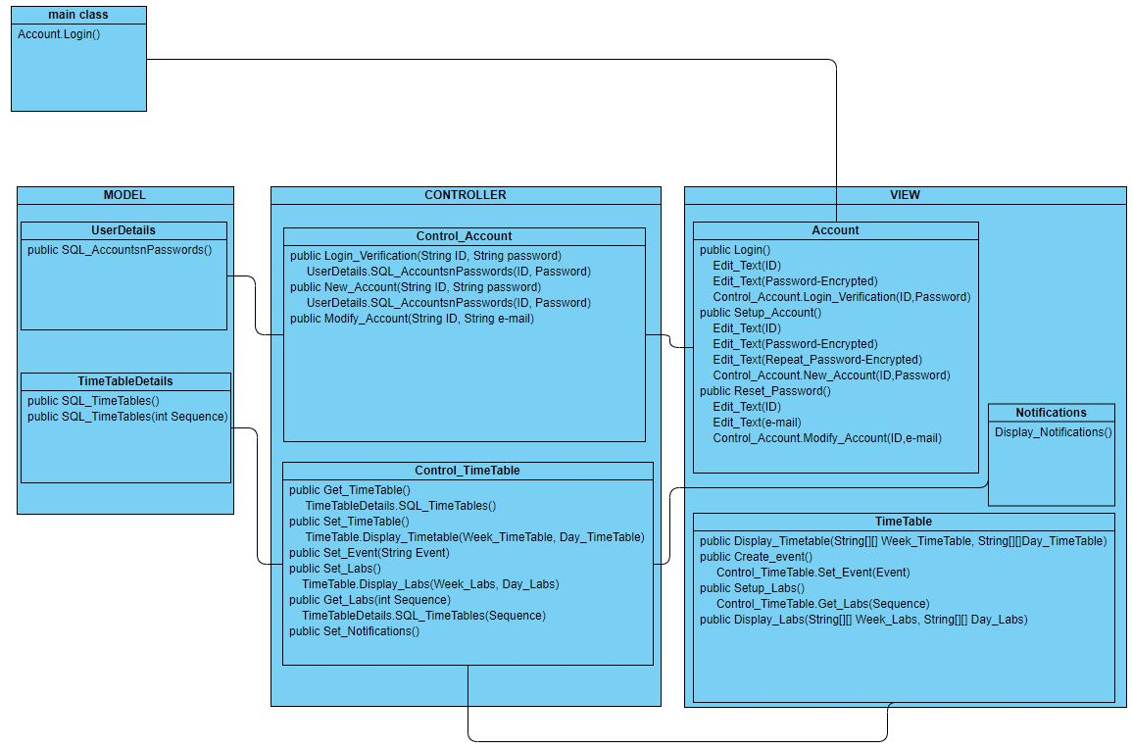

### CS2003 - Coursework discussion 3/12/2019

This module is assessed by 100% individual coursework submission. Full details of this assessment will be released online during term 1 (see below). The assessment relates to the learning outcomes 1, 2, and 3 for this module by requiring you to be able to:

1. identify and describe relevant usability engineering principles in the context of the usability evaluation report with references to the appropriate research literature.

2. explain and justify the role of the appropriate usability engineering methods and techniques within the context of the usability evaluation report.

3. design a usability engineering cycle (i.e. programme of work) for the development and evaluation of the application outlined in the usability evaluation report.

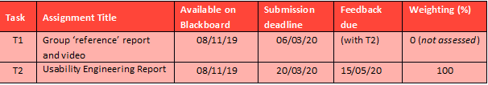

### Assignment Brief

# **Main Objective of the assessment**

#### You will conduct a usability engineering task around an application or device developed as a group project and written up in the form of a report. This assessment is intended to examine all of the cs2003 learning outcomes, as specified in the Learning Outcomes and Marking Criteria section below.

#### 

You will conduct a usability engineering task around an application or device developed as a group project and written up in the form of a report. This assessment is intended to examine all of the cs2003 learning outcomes, as specified in the Learning Outcomes and Marking Criteria section below.

# **Main Objective of the assessment**

You will conduct a usability engineering task around an application or device developed as a group project and written up in the form of a report. This assessment is intended to examine all of the cs2003 learning outcomes, as specified in the Learning Outcomes and Marking Criteria section below.

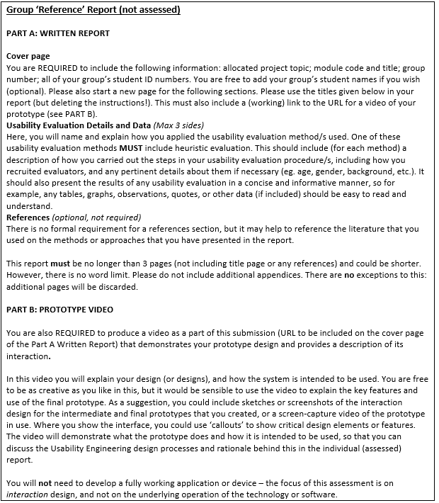

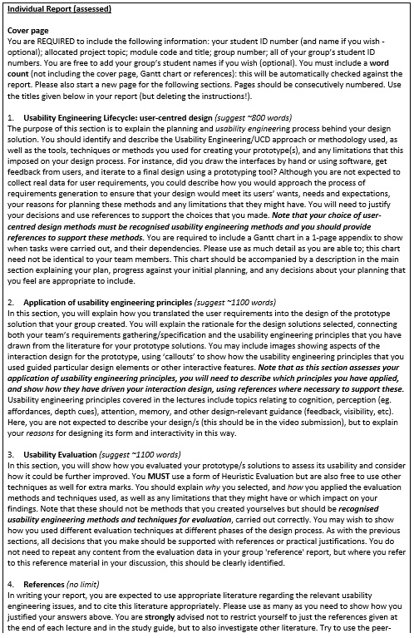



# **Submission Instructions**

You must submit each piece of coursework as a PDF file on Wiseflow by 06/03/20 at 11am (report 1) and 20/03/19 at 11am (report 2). You can follow the links to Wiseflow through the module’s section on Blackboard Learn or login in directly at https://uk.wiseflow.net/brunel. The name of your file should follow the normal convention set out in the student handbook and must therefore include your student ID number (e.g., 0612345.pdf). It can also include the module code (e.g., CS2003_0612345.pdf).

## Group Meeting Agenda 3/12/2019

### Assigned Work Discussion

1. Well done to members that have completed tasks
2. The project will now be entering into the implementation phase
3. Project files have been created
4. Discuss prototype implementation

### Work Completed This Week

1. Requirements Specification - Romi IN PROGRESS (Behind Schedule)
2. Risk analysis/Security - Camron IN PROGRESS (Behind Schedule)
3. GUI Design - Anthony NOT UPLOADED (Progress Tracking)
4. Class/Entity Relationship Diagram - Anas COMPLETE
5. Use Case Expansion - Franco COMPLETE
6. Database Class - Pruthvi ON SCEDULE
7. Terms & Conditions - Felipe ASSIGNED (Progress Report Needed)

### Work To Be Assigned

1. Notification - Romi TO BE ASSIGNED
2. Controll Timetable - Camron TO BE ASSIGNED
3. GUI - Anthony TO BE ASSIGNED
4. Control Account - Anas TO BE ASSIGNED
5. Account - Franco TO BE ASSIGNED
6. Database Class - Pruthvi TO BE ASSIGNED
7. Terms & Conditions - Felipe TO BE ASSIGNED